|  |  |  |  |
| --- | --- | --- | --- |
| cid:image024.png@01CE3435.D78287D0 | **Americas Capability Team**  **Capability log project** | |  |
|  |  |  |  |
| ***Key Enablers of Operational Excellence for Americas PSS Service Delivery.*** | | | |

**Objectives**

Develop a tool that provides visibility to projects handled by capability team.

**PACE Model**

|  |  |  |  |  |  |
| --- | --- | --- | --- | --- | --- |
|  |  | Name | T Number | Phone | Mail |
| **P** | rocess leader | Name 1 |  |  |  |
|  |  |  |  |  |  |
| **A** | pprover | Name 2 |  |  |  |
|  |  |  |  |  |  |
| **C** | ontributor | Name 3 |  |  |  |
|  |  |  |  |  |  |
| **E** | xecutor | Name 4 |  |  |  |
|  |  |  |  |  |  |

**Proposal:**

1. **Project menu**

Click this link to see project maintenance form

* Project maintenance
  + General information
    - Name
    - Description
    - Priority
    - Service line
    - Status
    - Category
    - Value stream
    - Average completed
  + Forecast time
    - Daily hours
      * Sum of all task daily hours
    - Forecast FTE required
      * Sum of all task daily FTE required
    - Start
    - End
    - Days completed since first task started
  + Tasks
    - Capability to show deleted tasks
    - Tasks detail(Data grid view)
      * Task ID
      * Task name
      * Start
      * End
      * Status
    - Show for every task selected in data grid
      * Daily hours
      * Daily hours required
      * Average completed
* Task maintenance

Click this link to see task maintenance form

* + General information
    - Name
    - Status
    - Start
    - End
    - Owner
      * Load information from users
    - Daily hours
    - Task FTE (Daily hours / 7)
    - Delete indicator
* Task input

Click this link to see Task input form

* + Project list(Data grid view)
    - Display columns
      * Project Id
      * Project name
      * Project description
  + Task list(Data grid view)
    - Display columns
      * Flag
      * Task Id
      * Task Name

1. **Maintenance menu**

* Users
  + T Number
  + Name
  + Profile
* Project category
  + ID
  + Description
* Project status
  + ID
  + Description
* Value stream
  + ID
  + Description
* Service line
  + ID
  + Description
* System
  + Forms
    - ID
    - Description
  + Profiles
    - ID
    - Description

1. **Win forms**

* Project maintenance form

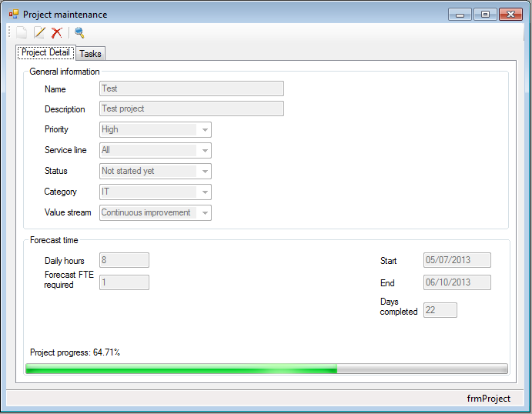

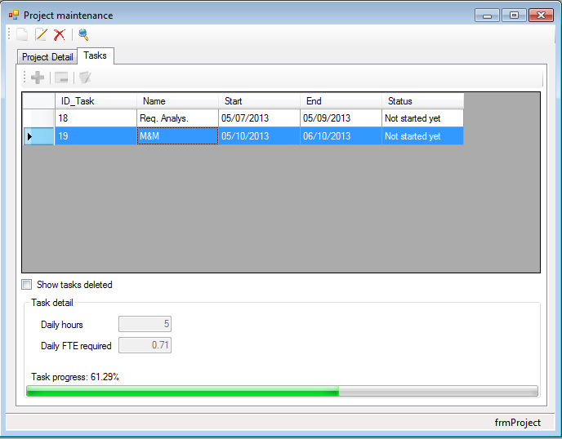

* Task maintenance form

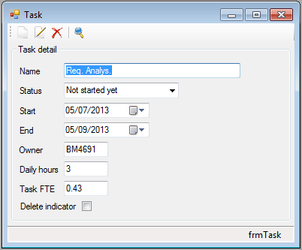

* Task input form

